Practical - 5
Practical Title: Registration Form with Frontend Validation and User-Friendly Error Handling
Problem Definition: Create a student registration form with HTML5 input types and JavaScript validation for name, email, mobile number, password, confirm password, course, year, gender, and terms acceptance. Use Regular Expression for validations.
1. Are correct input types and attributes used?
Answer: Yes, this matters a lot. Each field should use the type that matches what it's collecting, not just type="text" for everything:
- Email → type="email"
- Password → type="password"
- Phone number → type="tel"
- Age/roll number → type="number"
- Also add attributes like required, minlength, maxlength, pattern, and placeholder where useful.
Using the right type does two things: the browser gives built-in validation for free, and on mobile it shows the right keyboard (like a number pad for type="number").
2. Are validation errors displayed near the relevant fields?
Errors should show right below or next to the exact field that's wrong — not as one big alert box at the top, and definitely not a popup alert(). Example: if the password is too short, a small red text like "Password must be at least 8 characters" should appear directly under the password box. This way the user doesn't have to guess which field is the problem.
3. Is password strength checked?
Yes, it should be checked with JavaScript as the user types. A basic strength check looks for:
- Minimum length (usually 8+)
- At least one uppercase letter
- At least one number
- At least one special character (like !, @, #)
You can show this as text ("Weak" / "Medium" / "Strong") or a colored bar that updates live.
4. Is the form accessible using keyboard and screen-reader-friendly labels?
Two separate checks here:
- Keyboard: You should be able to fill the whole form using only Tab, Shift+Tab, and Enter — no mouse needed. Focus (the highlighted outline) should move in a logical order.
- Labels: Every input needs a real <label> connected to it using for="id" matching the input's id. This lets screen readers announce the field name properly. Just using placeholder text as a label is not enough — placeholders disappear once you start typing.

B. Implementation / Output / Result
The registration form (register.html) was built with semantic HTML5 form controls and the correct input type for every field — email, tel and password — along with a required attribute and a <label for="..."> tied to each input's id. A JavaScript file (script.js) validates every field using regular expressions, first in real time as the user types (input/change events) and again on submit. Each field has its own <span class="error"> placed directly below it, so an error message always appears next to the field that caused it, not in one combined alert. A live password-strength meter checks length and character variety and labels the password Weak, Medium or Strong as the user types.

C. Evidence of Work (Screenshots)
Registerion page :
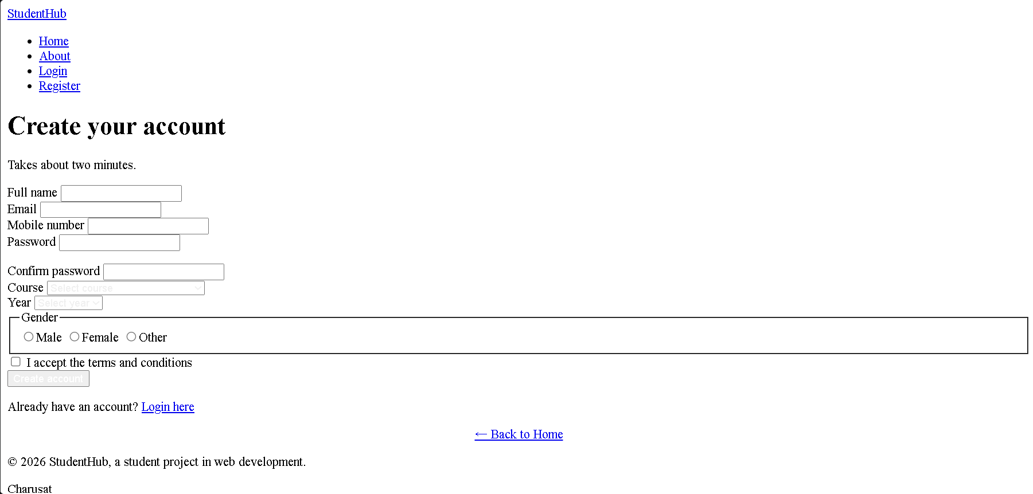

NOTE : this is whithout css , as css is not applied in this due to main javascript.

D. GitHub Repository Link :
https://github.com/kvvaghasiya49/Web_Development.git

E. Challenges Faced:
- Writing a mobile number regex that matched real Indian numbers (10 digits, starting 6-9) without also rejecting valid numbers took a few tries — the first version accepted numbers starting with any digit.
- Keeping the Confirm Password field in sync: if the user changed Password after already typing Confirm Password, the match check had to re-run automatically, so a listener was added on the password field to re-check confirmPassword too.
Building the password strength check with plain if/else score counting instead of a library, since only vanilla JavaScript was allowed for this practical.

F. Learning Outcomes:
- Learned how choosing the correct HTML5 input type (email, tel, password) gives free built-in validation and better mobile keyboards, on top of custom JavaScript checks.
- Learned to write and test regular expressions for real-world formats: names, emails, 10-digit mobile numbers, and strong passwords.
- Understood why inline, field-level error messages are better UX than a single alert box — the user knows exactly what to fix and where.
- Learned to build a simple password strength meter by scoring separate regex checks (length, uppercase, lowercase, digit, symbol) instead of one big pattern.

G. Faculty Remarks:

